Chapter 8
Computer Software

Lesson 8.1: Introduction and Classification
Lesson 8.2: Programming Languages
Lesson 8.3: Application Packages

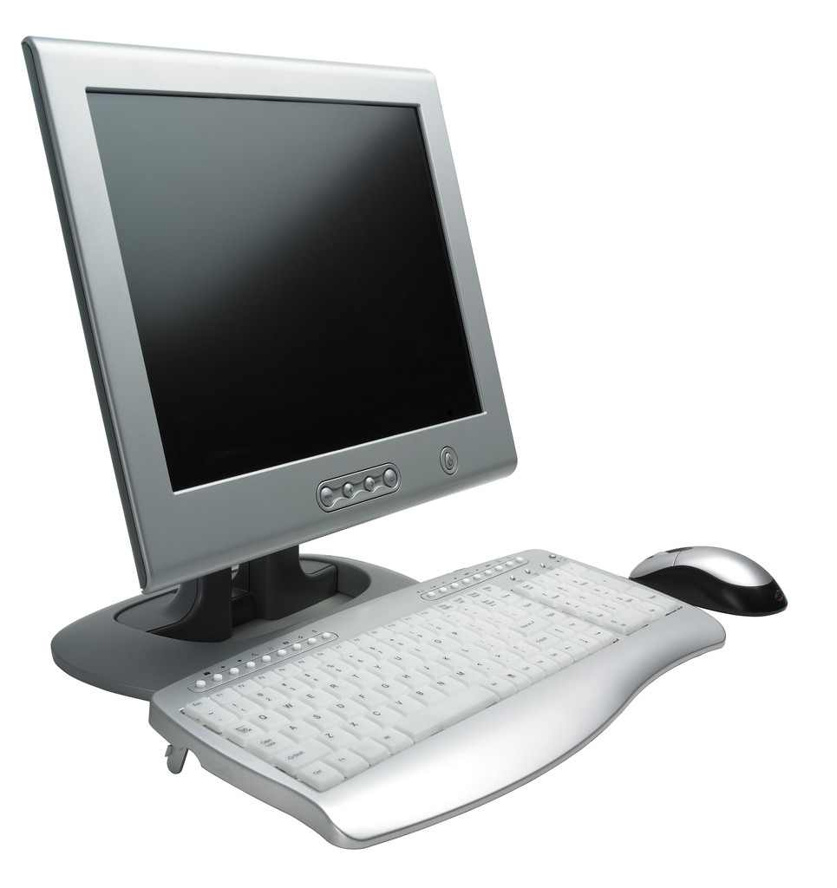

Lesson 8.1
Introduction and Classification

8.1.0 Objectives
On completion of this lesson you will know:
- Concept of software
- Difference between system software and application software
- Components of system software
- Types of application software

8.1.1 Software
Software of a computer system is intangible rather than physical. It is the term used for, any type of program. Software consists of statements, which instruct a computer to perform the required task. Without software a computer is simply a mass of electronic components. For a computer to input, store, make decisions arithmetically manipulate and output data in the correct sequence, it must have access to appropriate programs. Thus, the software includes all the activities associated with the successful development and operation of file computing system other than the hardware pieces. Hardware does the actual computing, and the software drives the computer. Figure 8.1.1 shows the communication between user and hardware. Software plays the role to connect the user and the hardware. The application software conveys the user intention to system software and the system software transfers and translates the intention for the hardware.
Software activities cover three major areas:
- Application programs,
- Systems programs, and
- Documentation.
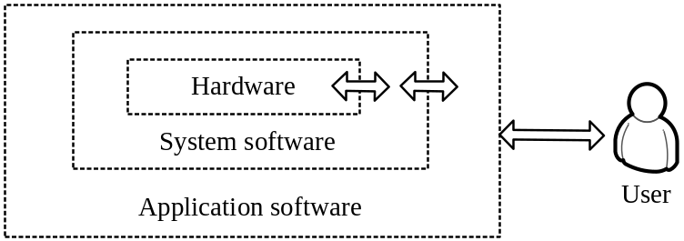
Figure 8.1.1: User and hardware communication
An application program is complete, self-contained computer program that performs a specific useful task, other than system maintenance functions. Application programs are the most familiar forms of software and come in a very wide variety. An application program also called ‘Application software’ or, simply 'Apps' in short.
System programs consist of programs associated with a computing system other than application programs. System programs are usually available from the computer manufacturer as a part of the overall system. They aid in the creation of application programs.
Documentation includes everything put down on paper, such as a statement of the problems, flowcharting, and coding, instruction sets and procedures etc. It plays an important role in software development.

8.1.2 Classification of Software
Software is generally classified as:
- System software
- Application software.
Figure 8.1.2 shows classification of computer software, system software consists of programs which facilitate the use of the computer by the users. These programs perform such standard tasks as organizing and maintaining data files, translating programs written in various languages to a form acceptable to the hardware, scheduling jobs as well as adding in other areas of computer operations. On the other hand, application software includes programs designed to perform specific user applications.

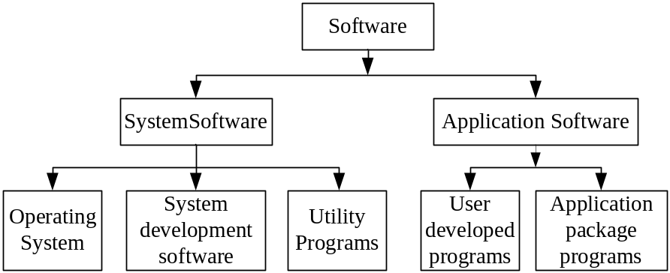
Figure 8.1.2: Classification of software
Application programs can be developed by the users themselves using suitable programming languages. There are many programming languages which allow us to write computer instructions in a text form. BASIC, FORTRAN, COBOL, PASCAL, C, C++, Java are some well known programming languages. However, writing application programs using such languages requires expertise and experience in programming and only experienced programmers can write good quality application programs.
Application software is controlled by system software, which manages hardware devices and perform background task. Figure 8.1.3 illustrates interaction between application software and system software which controls hardware of the system.
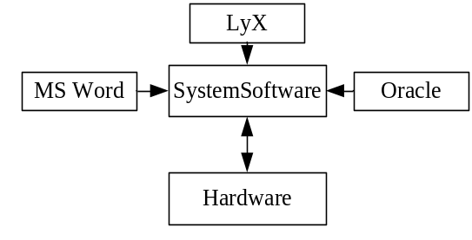
Figure 8.1.3: Relationship of application and system software
Many application programs are now available commercially. Such programs, developed by experienced programmers, can be readily employed for user applications. These programs are popularly known as application packages or simply packages. MS Word, WordPerfect, WordStar, LyX, and ‘OpenOffice.org Writer’ for word-processing, Lotus 1-2-3, MS Excel and ‘OpenOffice.org Calc’ for spreadsheet analysis and dBASE, FOXPRO, ORACLE, MS Access and ‘OpenOffice.org Base’ for database management are examples of popular application packages. Application programs fall into two categories:
- Horizontal applications and
- Vertical applications.
Horizontal Applications
These are general purpose programs that address the needs of many people, such as writing document (e.g., word processing), working with numbers (e.g., spreadsheets) and keeping tract of information (e.g., database). There are three types of horizontal applications.
Personal productivity programs: Most popular personal productivity programs are word processing programs, spreadsheet programs and database programs etc.
Multimedia and graphics programs: Popular presentation programs are MS Power Point, and Beamer in Latex etc.
Internet Programs: Common Internet programs are e-mail programs, web browsers etc.
Vertical Applications
These are generally designed for a particular line of business or for a division in a company, for instance, garments production tracking program, restaurant management program etc. Vertical software is designed for a customer to do specific jobs, which is known as custom software. Generally vertical software is costly due to small size of market.

8.1.3 Few Software Terminology
Commercial software or less commonly, payware, is computer software that is produced for sale or that serves commercial purposes. Commercial software is most often proprietary software, i.e. it is copyrighted and one must have to pay before using it.
Shareware software is also copyrighted software that one can use on a try before buy basis. If a user likes to buy it after using it for a specified trial period, the user must have to pay for the registration.
Freeware refers to copyrighted software given away free, with the understanding, that one can not sell it for profit. This type of software is also called open source software.
Firmware is a term often used to denote the fixed, usually rather small, programs and/or data structures that internally control various electronic devices. Typical examples of devices containing firmware range from end-user products such as remote controls or calculators, through computer parts and devices like hard disks, keyboards, TFT screens or memory cards, all the way to scientific instrumentation and industrial robotics.
Middleware is computer software that connects software components or some people and their applications. The software consists of a set of services that allows multiple processes running on one or more machines to interact. This technology evolved to provide for interoperability in support of the move to coherent distributed architectures, which are most often used to support and simplify complex distributed applications. It includes web servers, application servers, and similar tools that support application development and delivery.

8.1.4 Key Points
- Software of a computer system is intangible rather than physical
- Software consists of statements, which instruct a computer to perform the required task.
- Software activities cover three major areas: Application programs, systems programs, and documentation.
- System software consists of programs which facilitate the use of the computer by the users.
- An application program is complete, self-contained computer program that performs a specific task, other than system maintenance functions.
- Application programs can be developed by the users themselves using suitable programming languages.
- Application programs fall into two categories: Horizontal applications and Vertical applications.
- Shareware software is also copyrighted software that one can use on a try before buy basis.
- Freeware refers to copyrighted software given away free, with the understanding, that one cannot sell it for profit.
- Firmware is a term often used to denote the fixed, usually rather small, programs and/or data structures that internally control various electronic devices.
- Middleware is computer software that connects software components or some people and their applications.

8.1.5 Exercise
Multiple Choice Questions
- Broadly, two categories of software are __________.
  - System software and Horizontal software
  - Vertical software and Application software
  - System software and Application software
  - none of these
- Software activities cover __________.
  - Application programs
  - Systems programs
  - Documentation
  - All of them
- Which one is not system software?
  - Operating System
  - System Development Software
  - Utility Programs
  - Application Package Program
- __________ refers to copyrighted software given away free, with the understanding, that one cannot sell it for profit.
  - Freeware
  - Firmware
  - Shareware
  - Middleware
- __________ is not horizontal software.
  - MS Word
  - MS Access
  - MS Excel
  - none of these

Review Questions
- Define the terms: software, system software, application software and package program.
- Distinguish between hardware and software.
- List names of at least five package programs.
- Using a diagram, show the communication between user and hardware.
- Differentiate between horizontal and vertical applications.
- What is meant by custom software?
- What do your understand by shareware and freeware?

Analytical Questions
- What do you understand by the term software? Critically discuss classification of software.
- Write a note on application software.
- Discuss application programs with classification.

Lesson 8.2
Programming Languages

8.2.0 Objectives
On completion of this lesson you will know:
- Generations of programming languages
- Types programming languages.
- Features of some commonly used programming languages

8.2.1 Computer Languages
A Computer does not have a brain like ours and it cannot do anything by itself. A computer cannot understand human languages, so an instruction for a task has to be told in a special computer language. One can give an instruction to a computer which can be carried out straight away. It is also needed to store a set of instructions which are to be carried out over and over again or at a later time.
A set of instructions written in a computer language is called a program. Writing a program is called programming and the languages used are called programming languages. A program can be stored on a disk, so that it is available to be run when required.
Inside the computer, operations are done using electronic pulses. A special program translates instructions into electronic pulses that the computer can understand. In a program the instructions contain special words and symbols and the order of the words is very important. The pattern of electronic pulses for an instruction is called machine code. One could write instructions directly in machine code, but it is very difficult. In assembly language, instructions are given by short forms, called mnemonics. High level languages are much easier to understand than assembler mnemonics or machine codes. Instructions of a program written in high level languages are translated by computers, in machine language with the help of the compilers before execution. Programming languages can be classified on the basis of generations. These are as follows:
- First Generation Language (1 GL): For example, machine languages (based on 0 and 1)
- Second Generation Languages (2 GL): For example, assembly languages (based on special codes)
- Third generation Languages (3GL): For example, high level languages (similar to English language, e.g., BASIC, C etc)
- Fourth generation Languages (4GL): For example, nonprocedural languages.

First Generation: Machine Language
In machine language program, the computation is based on binary numbers. All the instructions including operations, registers, data and memory locations are given in there binary equivalent.
The machine directly understands this language by virtue of its circuitry so these programs are directly executable on the computer without any translations. This makes the program execution very fast. Machine languages are also known as first generation languages.
A typical low level instruction consists essentially of two parts:
- An Operation Part: Specifies operation to be performed by the computer, also known as Opcode.
- An Address Part: Specifies location of the data on which operation is to be performed.
Advantages of Machine Language
- Machine language makes most efficient use of computer system resources like storage, registers, etc. the instruction of a machine language program are directly executable so there is no need of translators.
- Machine language instruction can be used to manipulate the individual bits in a computer system with high execution speed due to direct manipulation of memory and registers.
Drawbacks of Machine Language
- Machine languages are machine dependent and, therefore, programs are not portable from one computer to other.
- Machine languages require programmers to control the use of each register in the computer’s Arithmetic Logic Unit and computer storage locations must be addressed directly, not symbolically.
- Machine language requires a high level of programming skill which increases programmer training costs.
- Programs written in machine language are more error prone and difficult to debug because it is very difficult to remember all binary equivalent of register, opcode, memory location, etc.
- Program size is comparatively very big due to non-use of reusable codes and use of very basic operations to do a complex computation.

Second Generation: Assembly Language
Assembly languages are also known as second generation languages. These languages substitutes alphabetic or numeric symbols for the binary codes of machine language. That is, Mnemonics can be used for all opcodes, registers and memory locations. These provide with a facility to write reusable code in the form of macros. A macro has two parts, one is macro name and the other is macro body which contains the line of instructions. A macro can be called at any point of the program by its name to use the instructions given in the macro repetitively.
Assembly languages require a translator known as “assembler” for translating the program code written in assembly language to machine language. Because computer can interpret only the machine code instruction, once the translation is completed the program can be executed.
Advantages of Assembly Language
- Assembly language provides optimal use of computer resources like registers and memory because of direct use of these resources within the programs.
- Assembly language is easier to use than machine language because there is no need to remember or calculate the binary equivalents for opcode and registers.
- An assembler is useful for detecting programming errors.
- Assembly language encourages modular programming which provides the facility of reusable code, using macro.
Drawbacks of Assembly Language
- Assembly language programs are not directly executable due to the need of translation.
- These languages are machine dependent and, therefore, not portable from one machine to another.
- Programming in assembly language requires a high level of programming skills and knowledge of computer architecture of the particular machine.

Third Generation: High Level Languages
All high level languages are procedure-oriented language and are intended to be machine independent. The high level languages use natural language like structures. These languages require translators (compilers or interpreters) for execution. The programs written in a high level language can be ported on any computer, that is why, they are known as machine independent.
These languages enable the programmer to write instruction using English words and familiar mathematical symbols which makes it easier than technical details of the computer. It makes the programs more readable too.
Procedures: Procedures are the reusable code which can be called at any point of the program. Each procedure is defined by a name and set of instructions accomplishing a particular task.
Advantages of High Level Languages
- High Level Languages are easier to learn than assembly language.
- These require less time to write programs.
- These languages provide better documentation.
- High Level Languages are easier to maintain.
- These offer better programming efficiency
- These have an extensive vocabulary.
Limitation of Programming language
- Usually long sequence statements are needed for every program.
- High level languages require additional memory space for storing compiler or interpreter.
- Execution time is very high as these programs are not directly executable.

There are several high level programming languages in use. Following computer languages are popular and have widespread applications: BASIC and Visual Basic (VB), C and C++, FORTRAN, PASCAL and Delphi, COBOL, Smalltalk, Java and JavaScript, HTML, Perl, C#, PHP etc.

Fourth Generation: Non-Procedural Languages
Fourth Generation languages are known as "declarative language" and do not require writing traditional programming logic. Programmers concentrate on defining the input and output rather than the program steps required in a procedural language such as C++ or Java. For example, a command, such as LIST, might display all the records in a file on screen, separating fields with a blank space. In a procedural language, all the logic for inputting each record, testing for end of file and formatting each column on screen has to be explicitly programmed. Query languages, report writers, interactive database programs, spreadsheets and application generators are examples of non-procedural languages.

8.2.2 Commonly Used High Level Programming Languages
BASIC, QBASIC and Visual Basic: BASIC stands for Beginner's All purpose Symbolic Instruction Code. It is a comparatively easy language for beginners. Initially BASIC was the commonly used language for microcomputers. It was developed by J.G. Kemeny and Thomas Curtz of Dartmouth College of USA in 1964. Many different versions of BASIC are in use. Most microcomputers use QBASIC devised by a company called Microsoft. BASIC has several advantages over the other computer languages, they are:
- It is easy to learn and use.
- It presents several powerful additional facilities not available in many other languages.
- It is designed for interactive use rather than batch processing mode.
- The user can correct errors as and when they arise during program execution.
The language is easily adaptable on all computers. BASIC is easy and suitable for non-professionals. Microsoft Visual Basic (VB) is a widely used program development package. It is by far the most successful rapid application development (RAD) tool for Microsoft Windows applications. VB enables a programmer to develop an application quickly by designing the graphical user interface. The programmer doesn't have to worry about any of the code that generates the user interface; it is handled automatically by the VB compiler, which creates an executable program capable of running on its own. Using VB, even a novice programmer can develop an impressive application. A huge variety of accessory tools enable VB programmers to quickly accomplish tasks such as building interfaces to databases and increasing the functionality of Web pages.
VB script: It is a scripting language based on VB. It was created for writing scripts (short program) that can be embedded in Web pages.
C and C++: Dennis Ritchie, a programmer at AT&T Bell Laboratories in USA designed the C language in the mid 1970s. C allows a programmer to write code with low-level access to the hardware but with high-level structured programming concept. C is a popular language. C proved suitable for writing programs that had previously been written exclusively in assembly languages. AT&T UNIX operating system was written in C. The language is portable to microcomputers. Most PC applications and system programs are written in C.
A more recent version of C is C++, which, incorporates object oriented features, but does not force programmers to adhere to the object oriented model. Thus, it provides flexibility and the high execution speed. The C++ language is in widespread use for professional program development. Software giant Microsoft Corporation uses C++ for application development.
FORTRAN: FORTRAN stands for Formula Translation. It was the first programming language developed by IBM in 1957. FORTRAN 11 and FORTRAN IV are the most popular versions which were developed in 1966. Latest additions are FORTRAN 77 and FORTRAN 90. FORTRAN syntax is very rigid. It is popular in engineering and scientific calculations.
Pascal and Delphi: Pascal is popular on small computers. Pascal was designed and developed by Nicholas Whirth to teach computer programming to students. It belongs to ALGOL family. A Pascal program consists of nested blocks for structured programming. Like older programming languages, Pascal has been updated to reflect new approaches to programming. An object oriented version of Pascal provides the foundation for Delphi, a compiler created by Borland International that closely resembles Visual Basic.
COBOL: It stands for Common Business Oriented Language. It is a popular business language for data processing. It was designed in late 1960s with a view to provide a common language for business applications. COBOL is independent of any specific computer system, and thus a program written in the language can be transferred to another computer with marginal changes only.
CORBA: It stands for Common Object Request Broker Architecture, most commonly known as middleware. CORBA defines how objects can communicate with each other across a network, even if the objects are written in dissimilar programming languages. Microsoft Corporation has its own standard, called Component Object Model (COM), which works best in Windows platforms.
Smalltalk: Developed in the early 1970s at Xerox Corporation. Smalltalk is considered as 100 percent pure object oriented programming language. Although the language is not often chosen for professional software development, more than a few corporations have chosen Smalltalk for mission-critical applications. However, Smalltalk is facing stiff competition from the newest object-oriented languages on the scene, Java.
Java: It is one of the most powerful and relatively new programming languages. It is an object oriented programming language, created by Sun Microsystems, which is revolutionizing the programming applications for the World Wide Web (WWW) and corporate intranets and extranets. Java is similar to the C++ and is much simpler, secure and platform independent programming language. Java is also specifically designed for real-time, interactive, Web-based network applications. Java applications consisting of small application programs, called applets, can be executed by any computer and any operating system anywhere in a network.
The ease of creating Java applets and distributing them from network servers to client PCs and network computers is a major reason for Java's popularity. Applets can be small special-purpose application programs or small modules of larger application programs. Applets can reside at Web sites on a network server until needed by client systems, and are easy to distribute over the Internet, intranet or extranets. Applets are platform independent too - they can run on Windows, OS/2, UNIX and Macintosh systems without modifications.
Like VBScript, JavaScript is a scripting language designed for use on Web pages. JavaScript is not based on Java. It was created by Netscape Communications. It is simple, easy-to-learn language for writing scripts on Web pages, and it is in widespread use on the Web.
PHP: Hypertext Preprocessor is a widely used, general-purpose scripting language that was originally designed for web development to produce dynamic web pages. PHP code is embedded into the HTML source document and interpreted by a web server with a PHP processor module, which generates the web page document. As a general-purpose programming language, PHP code is processed by an interpreter application in command-line mode performing desired operating system operations and producing program output on its standard output channel. It may also function as a graphical application. PHP is available as a processor for most modern web servers and as a standalone interpreter on most operating systems and computing platforms.
PHP was originally created by Rasmus Lerdorf in 1995 and has been in continuous development ever since. The main implementation of PHP is now produced by the PHP Group and serves as the de facto standard for PHP as there is no formal specification. PHP is free software released under the PHP License.
HTML: It stands for HyperText Markup Language, it is a page description language that creates hypertext or hypermedia documents. HTML inserts control codes within a document at points that create link (known as hyperlink) to other parts of the documents or to other documents anywhere on the WWW. HTML embeds control codes in the ASCII text of a document that designate titles, headings, graphics, and multimedia components, as well as hyperlinks within the document. Several programs in the top software suites automatically convert documents into HTML formats. These include Web browsers, word processing and spreadsheet programs, database managers, and presentation graphics packages. These and other specialized HTML editor programs provide a range of features to design and create multimedia Web pages without formal HTML programming.
Perl: Perl is a high-level, general-purpose, interpreted, dynamic programming language. Perl was originally developed by Larry Wall in 1987 as a general-purpose Unix scripting language to make report processing easier. Since then, it has undergone many changes and revisions and become widely popular amongst programmers. Larry Wall continues to oversee development of the core language, and its upcoming version, Perl 6. Perl borrows features from other programming languages including C, shell scripting (sh), AWK, and sed. The language provides powerful text processing facilities without the arbitrary data length limits of many contemporary Unix tools, facilitating easy manipulation of text files. Perl gained widespread popularity in the late 1990s as a CGI scripting language, in part due to its parsing abilities. In addition to CGI, Perl is used for graphics programming, system administration, network programming, finance, bioinformatics, and other applications.
C#: C# (pronounced "see sharp") is a multi-paradigm programming language encompassing imperative, declarative, functional, generic, object-oriented (class-based), and component-oriented programming disciplines. It was developed by Microsoft within the .NET initiative and later approved as a standard by Ecma (ECMA-334) and ISO (ISO/IEC 23270). C# is one of the programming languages designed for the Common Language Infrastructure. C# is intended to be a simple, modern, general-purpose, object-oriented programming language. Its development team is led by Anders Hejlsberg. The most recent version is C# 4.0, which was released in April 12, 2010.

8.2.3 Some Other High Level Languages
ALGOL: It is a short name for Algorithmic Language. Originally developed in 1958, it is a more precision language than FORTRAN for scientific and numeric calculations.
Forth: It is a powerful language designed only for fourth generation computers. It is useful in home computing.
RPG: RPG Stands for Report Program Generator. It is a commercial language specially developed for reporting.
ADA: This language was designed by U.S. Defense Department for its real-time applications and is also suitable for parallel processing.
PL/1 (Programming Languages/1): This language combines the features of both COBOL and FORTRAN and can be used for scientific as well as business applications. It was introduced in the late 1960s by IBM. Its application is limited to only IBM computers.
Snobol: It was developed in 1962. It is quite different from other languages in the sense that it can be used for processing messages, patterns and strings.
LISP: LISP stands for List Processor. It is an artificial intelligence programming language,

8.2.4 Key Points
- A set of instructions written in a computer language is called a program.
- The languages which use only primitive operations of the computer are known as low level languages.
- In machine language program, the computation is based on binary numbers.
- Machine language makes most efficient use of computer system resources like storage, registers
- Assembly languages substitutes alphabetic or numeric symbols for the binary codes of machine language.
- Assembly language programs are not directly executable due to the need of translation.
- All high level language are procedure-oriented language and are intended to be machine independent.
- The programs written in a high level language can be ported on any computer
- High level languages enable the programmer to write instructions using words and familiar mathematical symbols
- High level languages offer better programming efficiency

8.2.5 Exercise
Multiple Choice Questions
- __________ is not 3GL language.
  - Visual Basic
  - C
  - Java
  - Assembly language
- C language was originally developed by __________-
  - Babbage
  - Jon Von Neuman
  - Denis Ritchie
  - none of them
- Which language is specifically designed for real-time, interactive and Web based network applications?
  - COBOL
  - BASIC
  - Java
  - none of these
- HTML stands for __________-
  - HyperText Markup Language
  - HyperText Making Language
  - Hyper Touch Markup Language
  - none of these
Review Questions
- Define the terms: high level language, source code and object code.
- Name the programs used for converting source code to object code.
- List the names of six high level languages.
- Write a note on programming language C.
- List the features of Java.
- Mention some features of HTML and PHP.
- List the features of VB.
Analytical Questions
- Name the levels of programming languages and discuss differences between them.
- Write a short essay on high level programming languages.
- Discuss the importance of Java and JavaScript for software development.
- Discuss the importance of C and C++ in current software development market.
- Discuss the importance of VB and VBScript for software development.
- Discuss the importance of HTML for Web applications.

Lesson 8.3
Application Packages

8.3.0 Objectives
On completion of this lesson you will know:
- Types and characteristics of application packages
- Names of common application packages
- Features of some popular packages.

8.3.1 Introduction
Package programs are developed by experienced programmers and marketed by software vendors for widely used applications. The package generally achieves the goals of lower cost and reduced risk of errors. Whenever feasible, the use of an appropriate application package should lie considered as an alternative to program development.
Integrated packages combine several applications into a single program package. Popular examples of integrated packages are Microsoft Word, WordPerfect, MS Office. Lotus 1-2-3, Symphony etc. The packages provide several standard applications such as word processing, spreadsheet analysis and databases. Data can be easily exchanged between the programs of integrated packages.
8.3.3 Examples of Package Program
There are many different kinds of package programs available in the market to solve user problems. Package programs are very popular and widely used in different disciplines. The main categories and their examples are given in Table 8.1.1.

Table 8.1.1: Popular Package programs
Categories | Popular Package Programs
Word Processors | Microsoft Office Word, Apple iWork, Bean, OepnOffice.org Writer, Latex, LyX, WordStar, WordPerfect etc.
Spreadsheets | Microsoft Office Excel, Apple iWork Numbers, OepnOffice.org Calc, Quicken, QuattroPro, SuperCalc, Lotus 1-2-3 etc.
Data Management | Microsoft Office Access, OepnOffice.org Base, Bean Sheet, ORACLE, dBASE, FoxBASE, Idealistic, SuperBase, Professional etc.
Integrated Software | PFS: First Choice, Microsoft Works, Enable OA, WordPerfect, MS Office etc.
Desktop Publishing, | PagePlus, Print Artist, The Print Shop professional, InDesign, Print Master, Microsoft Publisher, Quark Xpress, PFS: First Publisher etc.
Graphics | Adobe Photoshop, Adobe illustrator, PC Paintbrush, CorelDraw, GIMP, Adobe Flash, Scribus, 3D Studio Max, Maya, Blender etc.
Presentation | Microsoft Office PowerPoint, Flash, OepnOffice.org Impress, Apple Keynote, Corel Presentation, NXPowerLite etc.
CAD | AutoCAD, Eagle Eye, GMSolid, Generic CADD, TurboCAD, MicroGDS etc.
Communications | FreeSWITCH, Sound Recall, DGVox Voice Logger, CyberTech PRIME, NS, PDNS, OMNET++, CrossTalk, OpNet Modeler, MicroPhone, SmartCom 11, PC-Dialer, PC-Talk etc.
Educational | 3D Indiana, KidPix, MathTutor, Encarta, Google Earth, Matlab, BlueJ, Simcity, Spelling Bee, Fantavision, Freemind, Zoo Tycoon etc.
Decision Making Software | 1000Minds, Analytica, D-Sight, ERGO, MindDecider, Hiview3 etc.
Simulation | CircuitLogix, SPICE, Magic, ASCEND, NS2, Tortuza, Galatea etc.
Personal  Information Manager (PIM) | Microsoft Office Outlook, Kontact, iCal, NoteScribe, 3D Topicscave, OpenIRIS,Lotus Oraganriser etc.

8.3.2 Advantages of Package Programs
Advantages and benefits of using packages for popular applications are briefly outlined here.

Word Processing
- Document can be typed and then stored on a disk for later use.
- Easy text entry and editing
- On-screen formatting: such as bold, italic, underlining, and highlighting etc.
- Spelling checker, thesaurus, and grammar checker to improve accuracy of writing.
- A variety of print options to customize the text for printer.
- The capability to change the font and style of texts.
- The capability to interface with graphics and other software packages.
Spreadsheet Analysis
- Data entry can be automated and checked for errors.
- Easy editing.
- The column-and-row format is easy to understand and use.
- Formulas perform calculations and are saved with spreadsheet.
- One can sort, copy and move columns and rows with formulas intact.
- One can print a spreadsheet in a variety of formats.
- Built-in graph generator to create graphs from the data in a spreadsheet.
Data Management
- One can reuse the data access data easily, edit, sort, search, and arrange the data create report print labels etc.
- One can arrange data easily by using a database programmers search capabilities,
- Printing features enable one to generate mailing labels and reports.
Integrated Software
- Data are compatible among, applications. As an example, one can transfer data from database or spreadsheet to word processor or vice-versa.
- The menu system is generally the same, lessening the number of menus and options.
- Having an all-in-one package means that less time is spent for loading, opening and closing files.
- Integrated software costs less than the same number of applications purchased individually.
Desktop Publishing
- On-screen formatting and layout facility of text and graphics.
- The capability of assembling documents quickly and making changes easily.
- Import text from ally word processor or type text directly in the program.
- Print on a variety of printers, from dot-matrix printers to postscript laser printers,
Graphics and CAD
- One can use the art to create over and over again without losing the original quality.
- With on-screen graphics, it is not required to go back to the drawing board each time.
- One can make small modifications to the original art until achieving, the desired design.
- One can create a variety of charts easily with presentation graphic software.
- Most paint programs provide a variety of shading and filing, techniques.
- The art tools in a graphics program give control over the precision of creations.
- Draw programs produce graphics in postscript printer format.
- With graphics programs one can import art directly into popular desktop publishing programs.

8.3.3 Popular Package Programs
Microsoft Word: Microsoft Word (MS Word) possesses a wide range of powerful and easy-to-use features. Word is popular among PC and Mac users. Microsoft Word forms part of Microsoft Office. With Microsoft Word, one can integrate text with graphics and edit information within a document. Microsoft Word has special features such as print preview, side-by-side columns, built-in outlining, and automatic pagination. Word for Windows allows one to open multiple windows on the currently open documents or more than one document at one time. Word is designed to help print reports, memos, and documents and performs all the basic word processing techniques, such as deleting, italicizing, and highlighting. Word also has flexible tabs to produce great-looking tables and can mix fonts and font sizes easily. Microsoft Word has spelling checker, thesaurus, equation editor, sorting facility, drawing facility, spreadsheet facility to generate graphs and all undo commands. Many users prefer Word because of its compatibility to other systems. Using word it is possible to share data between PC and Mac systems. It is also compatible with WordPerfect for Windows, PageMaker and many other windows based software.
LaTeX: LaTeX is a document markup language and document preparation system. LaTeX is most widely used by mathematicians, scientists, engineers, philosophers, lawyers, linguists, economists, researchers, and other scholars in academia. As a primary or intermediate format, e.g., translating DocBook and other XML-based formats to PDF, LaTeX is used because of the high quality of typesetting achievable by TeX (a typesetting program). The typesetting system offers programmable desktop publishing features and extensive facilities for automating most aspects of typesetting and desktop publishing, including numbering and cross-referencing, tables and figures, page layout and bibliographies.
WordPerfect: WordPerfect (WP) is another popular word processing package. A full-featured word processor with an extensive range of features, WordPerfect appeals to users who demand many sophisticated tasks from their word processor. Easy text entry, powerful thesaurus and spell-checking routines, support for a wide range of fonts and printers, capability to create customs dictionaries, on-screen formatting, print preview, graphics interfacing and the column creating facilities are the main features of this program. WordPerfect also has a master document features for assembling one large document from a series of subdocuments, and a tutorial to help the inexperienced users. One also can use WordPerfect to program, to plan, and to draft Writing projects.
Microsoft Excel: Microsoft Excel is a commercial spreadsheet application written and distributed by Microsoft for Microsoft Windows and Mac OS X. It features calculation, graphing tools, pivot tables and a macro programming language called Visual Basic for applications. It has been a very widely applied spreadsheet for these platforms, especially since version 5 in 1993. Excel forms part of Microsoft Office. The current versions are 2010 for Windows and 2011 for Mac.
Lotus 1-2-3: Another popular spreadsheet package is Lotus 1-2-3. It combines three main features: spreadsheet, database and graphics. With lotus 1-2-3, users can create simple or complex spreadsheets, use the spreadsheet as a database, or graph spreadsheet information. A wide range of people use Lotus 1-2-3. From accounts to financial planners, business owners, and managers, Lotus 1-2-3 is the spreadsheet package of choice. 1-2-3's many features include an easy-to-use spreadsheet layout, an understandable control panel, a wide range of functions, easy printing procedures, graph creation and printing and macro capability. Lotus 1-2-3 for Windows is available.
Access: Access is the Microsoft's formidable desktop database platform. Access is designed for creating multiuser applications where database files are shared on networks, and Access incorporates a sophisticated security system to prevent unauthorized persons from viewing or modifying databases.
Access has a unique database structure that can combine all related data tables and their indexes, forms, reports, and VBA (Visual Basic for Applications) code within a single .mdb database file. Like all members of Office 2010, Access 2010 offers a variety of new Internet-related features for creating HTML documents for use in intranets and the Internet.
A primary reason for Access's success is that it duplicates on the PC desktop many of the features of Client/Server relational database systems, also called SQL database.
Microsoft Office: Microsoft Office is a non-free commercial office suite of inter-related desktop applications, servers and services for the Microsoft Windows and Mac OS X operating systems, introduced by Microsoft in 1989. Initially a marketing term for a bundled set of applications, the first version of Office contained Microsoft Word, Microsoft Excel, and Microsoft PowerPoint. Over the years, Office applications have grown substantially closer with shared features such as a common spell checker, OLE data integration and Microsoft Visual Basic for Applications scripting language. Microsoft also positions Office as a development platform for line-of-business software under the Office Business Applications brand. According to Forrester Research, as of June 2009, some version of Microsoft Office is used in 80% of enterprises, with 64% of enterprises using Office 2007.
On April 15, 2010, Office 2010 was released to manufacturing. The suite became available for retail and online purchase in June 2010. Office 2010 is the first version to require product activation for volume license editions. Office 2010 marks the debut of free online versions of Word, Excel, PowerPoint, and OneNote, which work in the web browsers (Internet Explorer, Mozilla Firefox, Google Chrome and Safari, but not Opera). Office Starter 2010, a new edition of Office, replaced the low-end home productivity software, Microsoft Works.
dBASE: The dBASE is an integrated software package; which has menu oriented database processing and programming facilities. It is a data manager; a piece of software that lets the user has freedom in the conceptualization and creation of databases for all types of business applications. Since business depends on timely information dissemination, the Value of a powerful programmable utility for database generation, maintenance, and query cannot be overstated. The dBASE can be executed on a variety of microcomputers, under any one of the popular operating systems. Different version of dBASE is known as dBASE III and dBASE III +, dBASE IV etc.
Microsoft Works: Microsoft Works is an integrated program that combines: word processing, spreadsheet, database and communications. Microsoft Works has enthusiastic following in both the PC and the Mac worlds. Because of easy features and friendly user interface, the applications in Microsoft Works are easy to understand and use. Its word processor enables one to enter, edit, save, and print texts and reports. Specialized search-and replace features, thesaurus and spelling checker also help to ensure the accuracy of work. Using Microsoft Works spreadsheet, one can create simple or complex works, perform what-if calculations, and use formulas. The data manager gives a great deal of flexibility in generating data-entry forms, working with fields, displaying data, and displaying generating reports. The communications module accesses the world outside a computer by transferring files to and from remote computers. Finally, the features in Microsoft Works can be used to format, merge data between applications, and exchange information with other programs and modules.
OpenOffice.org: OpenOffice.org, commonly known as OOo or OpenOffice, is an open-source application suite whose main components are for word processing, spreadsheets, presentations, graphics, and databases. It is available for a number of different computer operating systems, is distributed as free software and is written using its own GUI toolkit. It supports the ISO/IEC standard OpenDocument Format (ODF) for data interchange as its default file format, as well as Microsoft Office formats among others. As of November 2009, OpenOffice.org supports over 110 languages. OpenOffice.org comprises a collection of applications that work together closely to provide the features commonly included in modern office suites. Many of the components mirror those available in Microsoft Office. The components available include: Writer (Word processor similar to Microsoft Word and WordPerfect), Calc (Spreadsheet similar to Microsoft Excel and Lotus 1-2-3), Impress (Presentation program similar to Microsoft PowerPoint and Apple Keynote), Base (Database management program similar to Microsoft Access), Draw and Math.
Microsoft Outlook: Microsoft Outlook is a personal information manager from Microsoft, available both as a separate application as well as a part of the Microsoft Office suite. The current version is Microsoft Outlook 2010 for Windows and 2011 for Mac. Although often used mainly as an e-mail application, it also includes a calendar, task manager, contact manager, note taking, a journal and web browsing. It can be used as a stand-alone application, or can work with Microsoft Exchange Server and Microsoft SharePoint Server for multiple users in an organization, such as shared mailboxes and calendars, Exchange public folders, SharePoint lists and meeting schedules. There are third-party add-on applications that integrate Outlook with devices such as BlackBerry mobile phones and with other software like Office and Skype Internet communication. Developers can also create their own custom software that works with Outlook and Office components using Microsoft Visual Studio. In addition, Windows Mobile devices can synchronize almost all Outlook data to Outlook Mobile.
PFS: First Choice: PFS: First Choice, one of the most popular integrated packages for microcomputers combines the following applications:
- Word processing
- Database management
- Communications
- Spreadsheet
- Graphics.
It has a multitude of users from sophisticated business managers to the hobbyists. Some Users include business people who can type correspondence, balance books, and manage files, and business owners and managers who can analyze and maintain information. Other users include support staff working in data entry, creating visual presentations, or producing reports. PFS: First Choice automates many business tasks traditionally done by hand. With this program, one can perform accounting tasks, such as analyzing data and creating and printing spreadsheets. The word processor can be used to type correspondence, produce manuals, print documents, create presentations, and so on. PFS: first Choice also enables one to graph data, print graphs, plot graphs, create slide shows, and perform basic data-entry tasks. With the database management part of PFS: First Choice, one can design database forms, create mailing labels, edit and analyze data, update files, retrieve files, and create and print database reports.
PageMaker: PageMaker is a popular desktop publishing software package for microcomputers. Also called a page-composition program. PageMaker enables one to combine text and graphics on a page to compose documents. PageMaker accept text from a variety of popular word-processing programs and graphics in popular file formats. PageMaker can be used to format a page in a number of columns and formats, use different fonts, import sophisticated graphics, create on-screen graphics, create master pages, and perform many high-end functions. Although it is a high-end desktop publishing program, many people find the program easy to learn and use. Used with Microsoft Windows, PageMaker has familiar menus, pop-up dialog boxes and displays that most find easy to Understand and use.
Adobe Photoshop: Adobe Photoshop is a graphics editing program developed and published by Adobe Systems Incorporated. Adobe Photoshop Extended has extra features available. Adobe Photoshop Extended is included in all of Adobe's Creative Suite offerings except Design Standard, which includes the Adobe Photoshop edition. Alongside Adobe Photoshop and Adobe Photoshop Extended, Adobe also publishes Adobe Photoshop Elements and Adobe Photoshop Lightroom, collectively called "The Adobe Photoshop Family" by Adobe. In 2008, Adobe released Adobe Photoshop Express, a free Web-based image editing tool to edit photos directly on blogs and social networking sites. Adobe Photoshop has ties with other Adobe software for media editing, animation, and authoring. The .PSD (Photoshop Document), Photoshop's native format, stores an image with support for most imaging options available in Photoshop. These include layers with masks, color spaces, ICC profiles, transparency, text, alpha channels and spot colors, clipping paths, and duotone settings. This is in contrast to many other file formats (e.g. .EPS or .GIF) that restrict content to provide streamlined, predictable functionality.
Harvard Graphics: Harvard Graphics is a popular presentation graphics program for PC users. Used primarily in business, Harvard, Graphics is a feature-laden program with many enhancement options, but most users call find their way around easily. A comprehensive help system assists in learning the use of the software. Few features ofthe program are:
- The Chart Gallery, offering several chart types in a variety of formats.
- The Draw Utility, which can add and customize art to charts.
- The ability to put charts in an automated slideshow.
- The choice of animating arts giving the illusion of real animation in presentations.
- Supports for data imported from a variety of spreadsheet programs, such as Lotus 1-2-3 and Microsoft Excel.
- Output on display, printer, plotter, or film recorder devices.
- Templates and macro creating facility.
AutoCAD: AutoCAD is one of the best CAD programs in the market. It offers the following features:
- An easy-to-use interface with pull-down menus and dialog boxes.
- Support for a mouse or digitizer.
- Capability to layer, rotate, copy, mirror, move, stretch, and scale.
- 3D wire frame modeling.
- Many different views.
The version of Auto CAD which can be used with Microsoft Windows is easy-to-use.

8.2.5 Key Points
- Package programs are developed by experienced programmers.
- Integrated packages combine several applications into a single program package.
- Word processing is the creation of documents using a word processor.
- Spreadsheet is a computer application that simulates accounting worksheet.
- Data management comprises all the disciplines related to managing data as a valuable resource.
- Integrated software is software for personal computers that combines the most commonly used functions of many productivity software programs into one application.
- Desktop publishing combines a personal computer and page layout software to create publication documents on a computer both for large scale and/or small scale publishing.
- Computer-aided design (CAD), also known as computer-aided design and drafting (CADD), is the use of computer technology for the process of design and design-documentation.
- LaTeX is a document markup language and document preparation system.
- WordPerfect (WP) is popular word processing package.
- Microsoft Excel is a commercial spreadsheet application.
- Access is the Microsoft's formidable desktop database platform.
- Microsoft Office is a non-free commercial office suite of inter-related desktop applications.
- dBASE is an integrated software package; which has menu oriented database processing and programming facilities.
- Microsoft Works is an integrated program that combines: word processing, spreadsheet, database and communications.
- OpenOffice.org is an open-source application suite whose main components are for word processing, spreadsheets, presentations, and graphics.
- Microsoft Outlook is a personal information manager from Microsoft, available both as a separate application as well as a part of the Microsoft Office suite.
- PageMaker is a popular desktop publishing software package for microcomputers.
- Adobe Photoshop is a graphics editing program developed and published by Adobe Systems Incorporated.

8.2.6 Exercise
Multiple Choice Questions
- __________ is not word processing software.
  - MS WORD
  - WordStar
  - WordPerfect
  - MS Excel
- __________ is a database software.
  - MS WORD
  - ORACLE
  - dBASE
  - PC Paintbrush
- __________ is not a graphics software.
  - Harvard Graphics
  - PageMaker
  - Freelance Graphics
  - Access

Review Questions
- Distinguish between single application and integrated packages.
- List popular desktop publishing packages and database management packages.
- Mention some features of Microsoft word.
- List the features of a graphics program.
- List the features of a CAD program.

Analytical Questions
- What is an integrated package? Discuss its features and advantages. Give one example with its capability.
- What is a graphic package? Give at least two examples of graphic packages and the characteristics of any one of them.

